Installation and Maintenance Instructions for
GUARDIAN Traffic Controllers

A Note on SAFETY:

Traffic Controllers are an inherently destructive product. There are risks and liability involved in the use of traffic controllers. To minimize your exposure, it is extremely important that adequate safety measures are taken in the installation and use of traffic controllers. Warning signs are strongly recommended and are required by law in many areas. Illumination of the teeth, especially in areas of adjacent pedestrian traffic, is highly encouraged.

IMPORTANT NOTE FOR INSTALLATION OF ALL TRAFFIC CONTROL DEVICES:
Traffic Controllers must be installed in such a manner that traffic flows over the teeth at a strict 90-degree angle (perpendicular to the teeth). Complete vehicle alignment and perpendicular passage over the controller must be assured for front and rear axles. Allow for 15 to 20 feet in either direction of the traffic controller between any turns required of vehicles. Under no circumstances should traffic controllers be installed on a curve, or in an area where vehicles will not be assured of complete perpendicular passage over the traffic controller for front and rear axles. It is absolutely critical that traffic over the controllers be slowed to a maximum speed of 5 miles per hour. All traffic control units need to be positioned with the sharp edge of the teeth pointing TOWARD offending or wrong-way traffic.

These instructions are provided in order for you to receive maximum performance from your traffic control system. Failure to strictly follow these installation instructions will affect the performance of your traffic controllers. The positioning of the traffic controller and the angle of the teeth are critical to the proper function of the units. Failure to strictly follow these installation instructions will affect the angle of the teeth and can result in: broken teeth, broken springs, correct direction tire damage, inability to puncture tires of wrong-way traffic, and a multitude of other malfunctions. Antech Corporation will not be responsible for property, vehicle, tire, or personal damage resulting from improper installation. Antech Corporation will not be responsible for repairing malfunctions resulting from improper installation. Replacement parts needed in order to repair damage or malfunction caused by improper installation or abuse are not covered under your warranty.

INSTALLATION: In-Ground Models
For installation of GUARDIAN in-ground (or flush-mount) units, you will need excavating and cement mixing equipment (water, shovel, wheelbarrow, flat-trowel), up to 1 bag of cement, crushed rock, and 6 to 18 open web hollow blocks, depending on your preference.

To install in-ground units, excavate the placement area 24 to 36 inches deep, (depending on drainage needs in your area) by at least 84 inches long and 16 inches wide. Partially fill with
crushed rock and position the cement blocks as a base to support the top plate of the traffic controller unit at a level flush with the pavement surface to allow for proper drainage.

A handy technique to keep the controller unit level with the surface during installation is to bolt two flat steel bars, approximately 24 inches long, perpendicular to the unit to the top plate at either end, creating hold-bars. To do this, prepare the steel bars by drilling holes to match a pair of bolt-holes in the top plate. Next, bolt the bars perpendicular to the top plate using the existing pairs of bolts approximately 18 inches from each end of the unit. This creates temporary handles and flaps that will keep the controller unit level with the existing pavement while the cement cures.

Pour cement around the outside unit to set it in place, fill the excavation and even the pavement surface. Do not pour cement into the inside of the controller - pour only around the perimeter. Another efficient technique is to mix in approximately 2 to 3 shovels of hydraulic cement, such as “Pour Rock”, which speeds the water absorption and minimizes the cement curing time. After the cement has set and cured, unbolt the leveling-handles and replace the bolts in the top plate. Normal traffic may proceed over the controller.

MAINTENANCE of GUARDIAN Traffic Controllers:

Proper maintenance of GUARDIAN traffic control units consists of periodic inspection and removal of any leaves or material that may have become lodged inside the controller (dependent upon the site and elements in your area). Accumulated debris can be hosed out or manually cleaned out by unbolting the top-plate, which gives free access to the inner cavity of the unit.

With proper installation and maintenance of GUARDIAN Traffic Control systems, you will enjoy many years of cost-effective and reliable directional and access security.

LIMITED WARRANTY on GUARDIAN Traffic Control Systems

ANTECH CORPORATION, and its affiliates, warrants that the Traffic Control System, Electric Gate and Access Control Devices and related equipment installed shall be free from all defects in
material and workmanship for a period of Two years (24 Months) from the date of receipt under normal use and service unless manufacturer's warranty period is different and specifically excludes any work, products or wiring done by others. ANTECH'S obligation under this warranty is specifically limited to repairing or replacing, at its option, any defective part, which upon examination by ANTECH proves to be defective during the warranty period. This warranty shall not apply to any part which has been altered or repaired by any person not expressly authorized, by ANTECH, in writing to do so, or to any part which has been altered, subjected to misuse, accident or improper use.

There is no warranty of merchantability or fitness for any particular purpose nor is there any other warranty, express or implied, except as specifically stated in the above paragraph. ANTECH
does not represent that the products may not be compromised or circumvented; that the products will prevent any personal injury or property loss by burglary, robbery, fire or otherwise; or that the product will in all cases provide adequate warning or protection. Buyer understands that a
properly installed and maintained system may only reduce the risk of a burglary, robbery, fire or other event occurring without providing an alarm, but it is no guarantee that such will not occur or that there will be no personal injury or property loss as a result.

ANTECH shall in no event be liable for personal injury, property damage or other incidental or consequential damages nor for any special damages or any further loss, which may arise in connection with any claim. However, if ANTECH is held liable, whether directly or indirectly, for any loss or damage arising under this limited warranty or otherwise, regardless of the cause or origin, ANTECH'S maximum liability shall not in any case exceed the purchase price of the individual product or products which shall be the complete and exclusive remedy against ANTECH.

LATCH DOWN INSTRUCTIONS

Locate the two allen head screws in the 1 ½” slot midway on the top plate. (See drawing below) (In some cases there will be only one allen head screw in the slot) Loosen the screws and push both sections of teeth down with your hand taking care not to allow teeth to spring up and cause injury. Hold the teeth down below the top plate and slide the allen head screw mechanism to the other end of the 1 ½” slot. Tighten the screws securely. The teeth should now be in a lock down position. To unlock the teeth simply loosen the allen head screws taking care to keep hands and feet away from teeth. The teeth will pop up very quickly. Guardian Traffic Systems are not designed to be left in a latch down position for long periods. The teeth and shafts are zinc plated but may still be susceptible to rust which can cause the units to freeze in a lock down position when left immobile for long periods.
Surface Mount #1230.100
←

In Ground
#1130.100
#1160.100 → #1167.100
Thank you for your purchase of Guardian Traffic Controllers the finest and best engineered traffic controllers made. These units are built to last, employing the finest engineering, using the highest quality materials and precision fabricated. To insure your units provide long lasting service and safety please follow these installation and maintenance instructions.

If you have any questions do not hesitate to contact our customer service or engineering staff at 1.800.866.9115 (8:00 AM to 4:30 PM - MST). Thank you for choosing Guardian Traffic Systems.

WARNING

Traffic Controllers are by design intended to damage vehicle tires when they travel over them in the wrong direction. There are risks and liability involved in the use of traffic controllers. To minimize the inherent risks, it is extremely important that adequate safety measures are taken in the location, installation, maintenance and use of traffic controllers.

Traffic Controllers must be installed in such a manner that traffic flows over the teeth at a strict 90-degree angle to the unit and parallel to the teeth. Complete vehicle alignment and perpendicular passage over the controller must be assured for front and rear axles. Allow for a minimum of 10’ feet (3 m) in either direction of the traffic controller between any turns required of vehicles. Under no circumstances should traffic controllers be installed on a curve, or in an area where vehicles will not be assured of complete perpendicular passage over the traffic controller for front and rear axles. The positioning of the traffic controller and the angle of the teeth are critical to the proper function of the units.

It is absolutely critical that traffic over the controllers be slowed to a maximum speed of 5 miles per hour. A speed bump is recommended prior to the teeth. All traffic control units need to be positioned with the sharp edge of the teeth pointing TOWARD offending or wrong-way traffic.

Be sure that the units are kept free from debris. The units will not work properly if restriction occurs from debris buildup. Be sure to establish a routine cleaning of any debris that may build up in the units. The schedule of maintenance will to a great extent depend on the site conditions and the environment.

These instructions are provided for you to receive the maximum performance from your traffic control system. Failure to strictly follow these installation instructions will affect the performance of your traffic controllers.

Failure to strictly follow these installation instructions will affect the system and can result in: broken teeth, broken springs, correct direction tire damage, inability to puncture tires of wrong-way traffic and other malfunctions.

Signage

Warning signs are imperative to provide sufficient notice of the danger to drivers and to pedestrians and may be required by law in your area. Illumination of the teeth, especially in areas adjacent to pedestrian traffic, is also important if the area will be accessible after daylight. Be sure your customer is aware of these inherent dangers.

Therefore, it is recommended to use Guardian Warning Sign Model 1410.100 (lighted) or 1414.100 (reflective) that warns drivers of the inherent danger of the device including a notice for pedestrian traffic to stay clear of the area. If there will be traffic after dark be sure to provide adequate lighting in the area and use the warning sign Guardian Model 1410.100.

Maintenance

It is necessary to maintain your Guardian Traffic System Controllers consisting of periodic inspection insuring proper tooth and shaft movement and cleaning of any debris that may have settled or lodged inside the controller (dependent upon the site and elements in your area).

Accumulated debris can be hosed out or manually cleaned out by unbolting the top-plate, which gives free access to the inner cavity of the unit. If debris is allowed to build up the unit will malfunction which could cause damage to the unit or to vehicle tires traveling in the correct direction.

With proper installation and maintenance of Guardian Traffic System Controllers systems you will benefit from many years of cost-effective and reliable directional and access control.

INSTALLATION: Surface Mount Models

Guardian Traffic Systems Controllers can be installed using one of two methods of application or a combination of the two. The first is by bolting the units down to a concrete surface (not recommended for asphalt). The second is by affixing them to the road surface using epoxy in the case of asphalt road surfaces. The surface should be level and as smooth as possible. The units should not be installed on gravel, a highly irregular surface, an incline or curve.

Location & positioning

- Carefully determine the location for your Traffic Control Units. Locate so that when the tires of the vehicle pass over the teeth they are parallel to the teeth. Position the units so that the tires (both front and rear) when passing over do not strike the teeth at an angle as this could cause damage to the teeth and to the tire. Normally you would want the units placed approximately 10’ (3 m) into the lane.

- Clean the area with a broom or other method to insure a clean and dry surface.

- Mark the location with a chalk line or other suitable mark to assist in aligning and locating the units in the desired position. You may also place the individual segments in the location you wish to install them and then mark the location. Make sure the teeth are facing the correct way.

Concrete Surface Installation

- When bolting into concrete (not recommended for asphalt) drill holes in the road surface in the corresponding larger hole on each segment.

- Place your anchors per manufacturer’s instructions. Do not use an anchor that will stick up above the traffic control unit that could cause damage to the passing tires. The recommended anchor is a Large Diameter Tapcon or “LTD” by ITW Ramset/Red Head or similar.

Asphalt Surface Installation

- If your surface is asphalt the best method of application is using Ultra-bond Epoxy supplied by Guardian Traffic Systems or your local hardware vendor.

- Turn the segments on their backs several inches in front of the installation location. The epoxy has a relatively short setting time and proper positioning of the segments can be facilitated by having them aligned and positioned close to the installation location.

- Place the end sections, if used, on their backs along side the toothed segments at the proper ends.

- Check all the interlocking tabs to make sure that they are correct.

- Check again to make sure the area is dry and clean of any debris to insure the best bonding of the epoxy.

- Follow the epoxy manufacturer’s instructions for mixing and preparing the epoxy that will be used to affix the segments to the drive surface. It is advised that several items including rags, cardboard or the like be available for clean up of any epoxy overrun that may be encountered during installation.

- Start with an outside-toothed segment (the epoxy should be applied to the toothed segments first and then end sections last if you are using them).

- Apply a coating of epoxy along the front edge and back edge and along each cross member coating all parts that will contact the road surface.

- After application of the epoxy turn the segment over and place in the previously marked position. Check the teeth position to make sure they are in the correct direction for the traffic flow.

- Proceed with the next segment inline, following the same procedure and installing them with the interlocks securely in place.

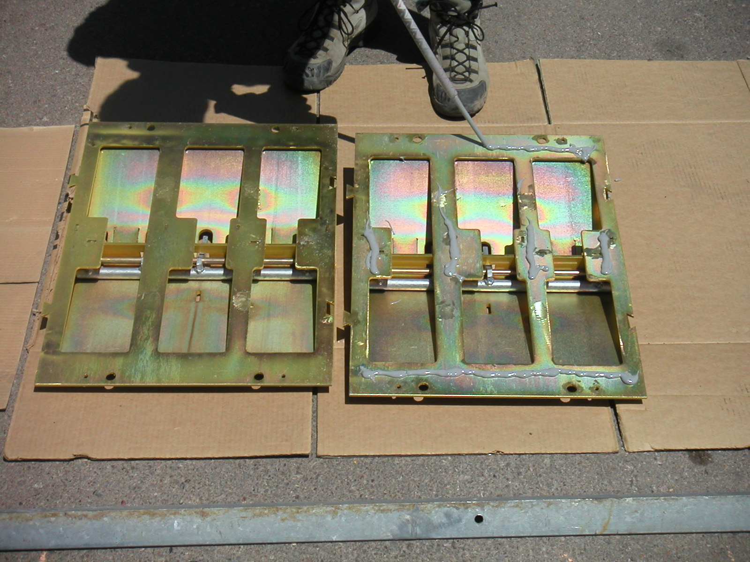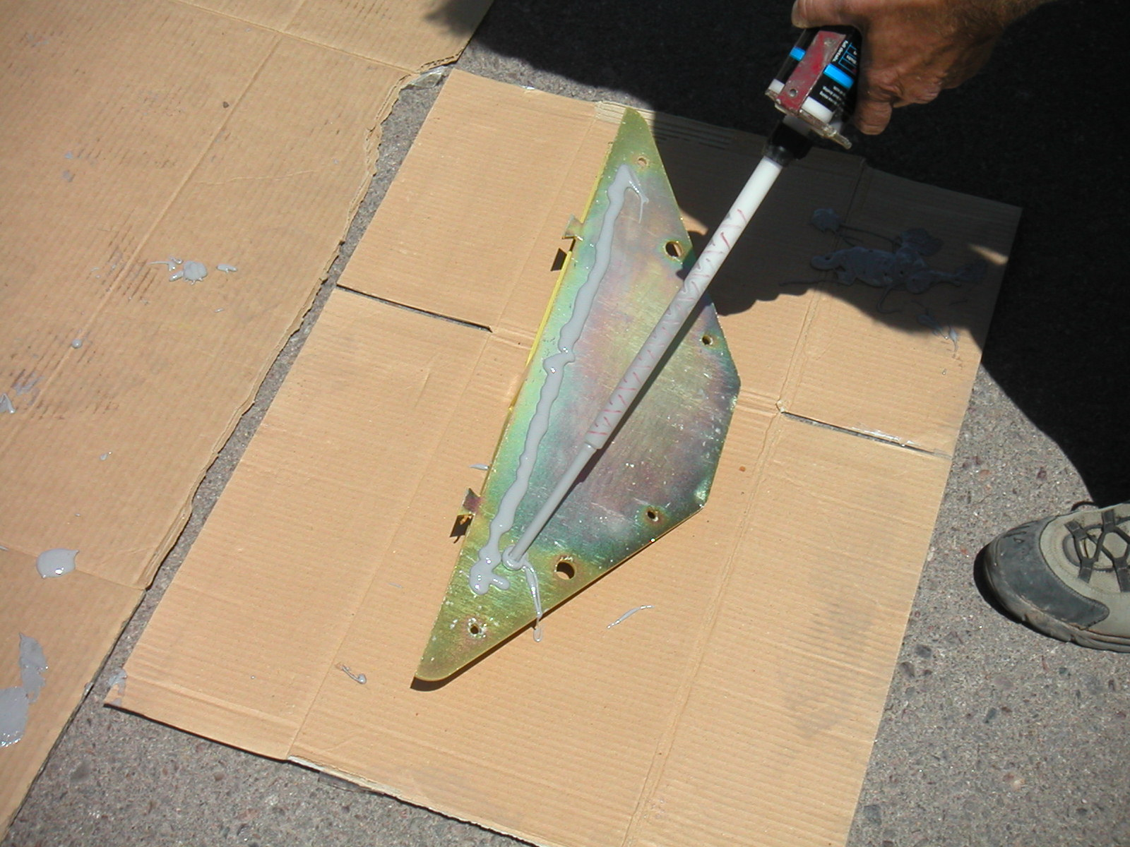

Figure 1 Figure 2

- After all the toothed segments are installed, the end sections (if used) can then be installed in a like manner (Fig 2).

- Be sure to apply the epoxy as recommended to insure the proper distribution of the epoxy for the maximum adhesion of each segment.

- After all the segments and end section are in place you may then nail the units to the road surface using hardened nails. This is desired to insure the units stay fixed and do not move while the epoxy sets.

- It is recommended that a sufficient time be allowed for the Epoxy to set before traffic is allowed to pass over the traffic controllers. The time allowable time will depend on the environment where the units are being installed and the epoxy being used. Check the epoxy manufacturer’s recommendations.

Latch Down Instructions

Although, your traffic system comes with a latch down assembly, Guardian Traffic Systems are not designed to be left in a latch down position for long periods. The teeth and shafts are zinc plated but may still be susceptible to rust which can cause the units to freeze in a lock down position when left immobile for long periods.

To use locate the two Allen head screws in the slot midway on the top plate (see drawing below). Loosen the screws and push both sections of teeth down with your hand taking care not to allow teeth to spring up and cause injury. Hold the teeth down below the top plate and slide the Allen head screw mechanism to the other end of the slot. Tighten the screws securely. The teeth should now be in a lock down position. To unlock the teeth simply loosen the Allen head screws taking care to keep hands and feet away from teeth. The teeth will pop up very quickly.

Surface Mount #1230.100 - 200
←

In Ground →
#1130.100
#1160.100 #1167.100

LIMITED WARRANTY

GUARDIAN TRAFFIC SYSTEMS LLC, warrants that the Traffic Control Units, Access Control Devices and related equipment sold shall be free from all defects in material and workmanship for a period of Twelve (12) Months from the date of invoice under normal use and service. GUARDIAN’S obligation under this warranty is specifically limited to repairing or replacing, at its option, any defective part, which upon examination by GUARDIAN proves to be defective during the warranty period. This warranty shall not apply to any part which has been modified, altered or repaired by any person not expressly authorized, by GUARDIAN, in writing to do so, or to any product which has been improperly installed, or unsatisfactory site conditions or parts or units that have been subjected to misuse, accident or improper use.

There is no warranty of merchantability or fitness for any particular purpose nor is there any other warranty, express or implied, except as specifically stated in the above paragraph. GUARDIAN does not represent that the products may not be compromised or circumvented; that the products will prevent any personal injury or property loss by burglary, robbery, fire or otherwise; or that the product will in all cases provide adequate warning or protection. Buyer understands that a properly installed and maintained system may only reduce the risk of a burglary, robbery, fire or other event occurring without providing an alarm, but it is no guarantee that such will not occur or that there will be no personal injury or property loss as a result.
GUARDIAN shall in no event be liable for any direct, indirect, personal injury, property damage, incidental, reliance, special or consequential damages, or damages for loss of profits, revenue, equipment or supplies by you or any third party, under any theory of liability, whether in an action in contract or tort, arising in connection with any claim. However, if GUARDIAN is held liable, whether directly or indirectly, for any loss or damage arising under this limited warranty or otherwise, regardless of the cause or origin, GUARDIAN’S maximum liability shall not in any case exceed the purchase price of the individual product or products which shall be the complete and exclusive remedy against GUARDIAN.
Any legal action or proceeding relating to your use of GUARDIAN Products shall be instituted in a state or federal court in Pima County, Arizona. You and GUARDIAN agree to submit to the jurisdiction of, and agree that venue is proper in, these courts in any such legal action or proceeding.
This warranty may vary from State to State and certain restrictions may apply.

Copyright © 2005 GUARDIAN TRAFFIC SYSTEMS LLC

