Installation, Maintenance and Repair Instructions

Model #1320 ENFORCER Surface Mount Electro-Mechanical Traffic Controller
And #1310 ENFORCER In-Ground Electro-Mechanical Traffic Controller

1. Lay out all components of the traffic controller (motor control tower, tunnel assembly, teeth and top plate assembly, and end bevel) as they will be when installed. Standard execution is to locate the operator on the left side of the traffic lane. (See Diagram 1. attached)

2. Check to make sure there are no obstructions in the traffic lane and check for proper traffic flow angles. Traffic controllers must be installed in such a manner that traffic flows over the teeth at a strict 90-degree angle (perpendicular to the teeth). Complete vehicle alignment and perpendicular passage over the controller must be assured for both the front and the rear tires. Traffic controllers must not be installed on any curves, slopes, grades, or anywhere that immediate turns are required before or after the units.

3. Use epoxy (part #1425.100 or equivalent. Always follow manufacturers directions) to affix the operator and tunnel section if placing on asphalt. Use ½” diameter lag bolts and insert if placing on concrete. For in-ground units (See Diagram 4. attached)

4. Remove the top plate assemblies of the tunnel and tooth sections. (See Diagram 1. attached)

5. Bolt or epoxy all tooth section bottom plates to concrete or asphalt.

6. Bolt the tunnel and tooth section bottom plates together.

7. INSTALLATION: In-Ground Models
For installation of GUARDIAN in-ground units, you will need excavating and cement mixing equipment (water, shovel, wheelbarrow, flat-trowel), a standard application will require a minimum of 1 yard of 2500 P.S.I premix cement, crushed rock, and 6 to 18 open web hollow blocks (standard 8x8x16 CMU’s), depending on your preference.

Installation, Maintenance and Repair Instructions

Model #1320 Surface Mount Electro-Mechanical Traffic Controller
and #1310 In-Ground Electro-Mechanical Traffic Controller

(continued)

NOTE: Always check with local municipality and utility company for regulations, codes and inspection of site prior to excavation.
To install in-ground units, excavate the placement area 24 to 36 inches deep, (depending on drainage needs in your area) by at least 36 inches long and 16 inches wide, per unit installed. Partially fill with crushed rock and position the cement blocks as a base to support the top plate of the traffic controller unit at a level flush with the pavement surface to allow for proper drainage (See Diagram 4 and 5. attached). Additionally, to excavate for motor control tower of in ground unit. This placement area will be 24 inches deep by a minimum of 28 inches long and 26 inches wide. Partially fill with crushed rock to a depth of 12 inches. Position casting form (optional accessory), with the 20 inch long dimension parallel to the traffic controller tunnel sections (note: rebars on casting form will be perpendicular to traffic controller tunnel when accurately located). Be sure casting form is centered and flush to traffic controller tunnel excavation area and bottom of casting form is at same elevation as bottom of traffic controller tunnel. Important! At this time locate power source conduit, if it is to be below ground, before pouring concrete.

NOTE: A handy technique to keep the controller unit level with the surface during installation is to bolt two flat steel bars, approximately 24 inches long, perpendicular to the unit to the top plate at either end, creating leveling-handles. To do this, prepare the steel bars by drilling holes to match a pair of bolt holes in the top plate. Next, bolt the bars perpendicular to the top plate using the existing pairs of bolts approximately 18 inches from each end of the unit. This creates temporary handles and flaps that will keep the controller unit level with the existing pavement while the cement cures. This technique applies when locating motor control tower casting form by properly positioning rebar leveling-handles (See Diagram 5. attached)

Pour cement around the outside unit to set it in place, fill the excavation and even the pavement surface. Do not pour cement into the inside of the controller or the casting form - pour only around the perimeter. Another efficient technique is to mix in approximately 2 to 3 shovels of hydraulic cement, such as “Pour Rock”, which speeds the water absorption and minimizes the cement curing time. After the cement has set and cured, unbolt the leveling-handles and replace the bolts in the top plate. Normal traffic may proceed over the controller.

Installation, Maintenance and Repair Instructions

Model #1320 Surface Mount Electro-Mechanical Traffic Controller
and #1310 In-Ground Electro-Mechanical Traffic Controller

(continued)

8. With the tooth section located so that the coupling shaft will connect with the opposite connecting shaft, slide the entire tooth section so that it is flush against the operator tunnel.

9. Repeat the alignment and connection process for any and all remaining tooth sections, bolting or using epoxy to fasten down each section once the sections are all connected. Tighten all hex head screws so each tooth section is attached to the next tooth section and the tunnel shaft.

10. Place the end bevel (surface mount only) at the end of the last tooth section, bolt it to the adjacent tooth section and then bolt or epoxy it down.

11. Reinstall the top plates of the teeth sections and the operator tunnel.

12. REPAIR or replacement of shear bolt (See Diagram 3. attached)
In the event that the traffic controller teeth fail in the closed position (the down position), proceed as follows. Tools required: Hammer, 1/8” diameter by 2 inch long shaft drift punch, 9/16 end wrench or equivalent socket and shear bolt (shear bolt supplied with motor control tower, quantity of 3).

a). Remove access plate located below motor control tower. This will require removing 4
9/16 bolts and will expose the tunnel shaft.

b). Remove damaged remaining shear bolt. This may require punching out through shaft.

c). Replace shear bolt with supplied ¼” shear bolt and nut.

d). Replace access plate with all 4 bolts and reactivate system.

Installation, Maintenance and Repair Instructions

Model #1320 Surface Mount Electro-Mechanical Traffic Controller
and #1310 In-Ground Electro-Mechanical Traffic Controller

(continued)

MAINTENANCE

It is necessary to maintain your Guardian Traffic System Controllers consisting of periodic inspection insuring proper tooth and shaft movement and cleaning of any debris that may have settled or lodged inside the controller (dependent upon the site and elements in your area).

Accumulated debris can be hosed out or manually cleaned out by unbolting the top-plate, which gives free access to the inner cavity of the unit. If debris is allowed to build up the unit will malfunction which could cause damage to the unit or to vehicle tires traveling in the correct direction.

With proper installation and maintenance of Guardian Traffic System Controllers systems you will benefit from many years of cost-effective and reliable directional and access control.

ELECTRICAL

Refer to operator manual supplied with all Electro-Mechanical Traffic Control Systems upon shipping. This manual can be found in an envelope attached to the top of the barrier gate operator.

LIMITED WARRANTY

Devices and related equipment sold shall be free from all defects in material and GUARDIAN TRAFFIC SYSTEMS LLC, warrants that the Traffic Control Units, Access Control workmanship for a period of Twelve (12) Months from the date of invoice under normal use and service. GUARDIAN’S obligation under this warranty is specifically limited to repairing or replacing, at its option, any defective part, which upon examination by GUARDIAN proves to be defective during the warranty period. This warranty shall not apply to any part which has been modified, altered or repaired by any person not expressly authorized, by GUARDIAN, in writing to do so, or to any product which has been improperly installed, or unsatisfactory site conditions or parts or units that have been subjected to misuse, accident or improper use.

(continued)

There is no warranty of merchantability or fitness for any particular purpose nor is there any other warranty, express or implied, except as specifically stated in the above paragraph. GUARDIAN does not represent that the products may not be compromised or circumvented; that the products will prevent any personal injury or property loss by burglary, robbery, fire or otherwise; or that the product will in all cases provide adequate warning or protection. Buyer understands that a properly installed and maintained system may only reduce the risk of a burglary, robbery, fire or other event occurring without providing an alarm, but it is no guarantee that such will not occur or that there will be no personal injury or property loss as a result.
GUARDIAN shall in no event be liable for any direct, indirect, personal injury, property damage, incidental, reliance, special or consequential damages, or damages for loss of profits, revenue, equipment or supplies by you or any third party, under any theory of liability, whether in an action in contract or tort, arising in connection with any claim. However, if GUARDIAN is held liable, whether directly or indirectly, for any loss or damage arising under this limited warranty or otherwise, regardless of the cause or of the individual product or products which shall be the complete and exclusive remedy against GUARDIAN.
Any legal action or proceeding relating to your use of GUARDIAN Products shall be instituted in a state or federal court in Pima County, Arizona. You and GUARDIAN agree to submit to the jurisdiction of, and agree that venue is proper in, these courts in any such legal action or proceeding.
This warranty may vary from State to State and certain restrictions may apply.

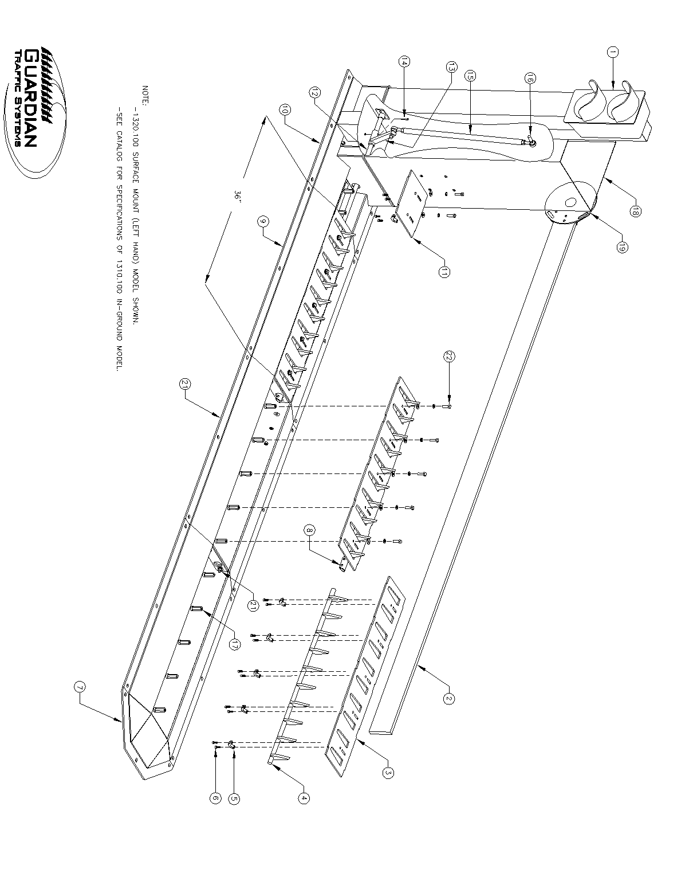

1310-1320 ELECTRO/MECHANICAL PARTS LIST
GUARDIAN TRAFFIC CONTROL SYSTEMS
PART NO. | PART NAME | DESCRIPTION | QTY.
1 | STOP-GO LIGHT | OPTION-SEE CATALOG | 1
2 | GATE ARM | OPTION-SEE CATALOG | 1
3 | TOP PLATE |  | 1*
4 | TOOTH SECTION/SHAFT | 35 1/2" LONG | 1*
5 | RETAINER CAP | 7/8 ID | 5*
6 | RETAINER SCREWS | 1/4-28UNF x 1/2 LG. SHCS | 10*
7 | END BEVEL | 1320.100 MODEL ONLY | 1
8 | SHAFT CONNECTOR | W/(2) 3/8-16UNC x 1 1/4 LG. SHCS | 1*
9 | TRAFFIC CONTROLLER ASSEMBLY | 36" LONG - 3 PER ORDER | 1
10 | ELEC./MECH. OPERATOR BASE |  | 1
11 | OPERATOR BASE TOP PLATE |  | 1
12 | TUNNEL SHAFT | 24" LONG | 1
13 | PITMAN ARM |  | 1
14 | SHEAR BOLT | 1/4-20UNC x 2 LG HEX BOLT | 1**
15 | LINKAGE ASSEMBLY | WITH TWO BALL JOINTS | 1
16 | BALL JOINT |  | 2
17 | STAND-OFF | 3/8-16UNC x 1 3/4 LONG | 5*
18 | ELEC/MECH GATE OPERATOR |  | 1
19 | GATE ARM ATTACHMENT ASSY. | FOR ATTACHING PART #2 | 1
20 | TRAFFIC CONTROLLER BASE | 1320.100 MODEL SHOWN | 1
21 | BOLT | 3/8-16UNC x 1-1/4 LG SS HEX BOLT
22 | TOP PLATE BOLTS | 3/8-16UNC x 1-1/4 LG SS HEX BOLT | 5*
* QUANTITY SUPPLIED WITH EACH 36" ASSEMBLY
** 3 SPARES SUPPLIED WITH SHIPMENT OF NEW PURCHASE
NOTE: PART #16 LINKAGE ASSEMBLY IS SUPPLIED WITH TWO BALL JOINTS (PART #17). LINKAGE
IS RIGHT OR LEFT HAND SPECIFIC. LEFT HAND MODEL 1320.100 IS SHOWN IN ILLUSTRATION.

